uu1ds*VILNIAUS UNIVERSITETAS

MATEMATIKOS IR INFORMATIKOS FAKULTETAS

INFORMACINIŲ TECHNOLOGIJŲ KATEDRA

**Duomenų bazių valdymo sistemos**

Projektinis darbas

Atliko: 2 kurso studentai:

Vytenis Alaburda

Arnas Jonynas

Justinas Lekavičius

Darbo vadovas: Agnė Brilingaitė

Vilnius – 2018

3. Political debates

ALL ENTITIES

PARTY, PARTY_APPEARENCE ,DEBATE ,POLITICIAN , EMPLOYEE ,QUESTION, VIEWERS, LOCATION, TOPIC

Description:

Political debates are discussions involving political candidates debating on various topics important to the well-being of society. The debates have numerous employees working behind the scenes. Furthermore, debate events are broadcast by a number of television networks. The debates take place in various locations across the United States of America. Discussed topics are the fundamentals of the debates, each having their own name and topic number, as well as relevant theme. The debates also have participating viewers that watch the events and ask questions. Politicians participate in debates and belong to a certain party, as well as answer questions.

* Every location has a designated address consisting of state, city, street and street number.
* A politician cannot be without a party (unless stated as independent) and a politician may only belong to one party.
* Viewers may not exist without the debates.
* Every employee has a specific role.
* Several questions that relate to several topics may be brought up during the debates, and a number of debates may have the same topics discussed. Questions may either be relevant or irrelevant to debates.
* A party may have a representative appearance made up of a single slogan and multiple colors.

**ER:**

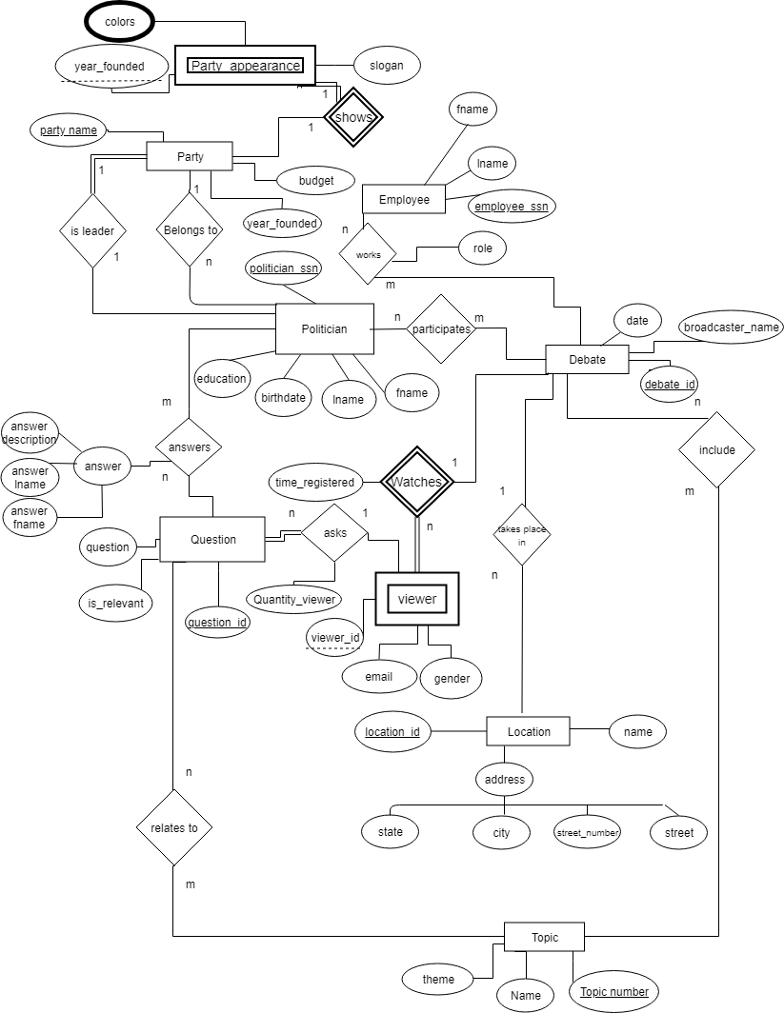

**RM:**

****Primary key \*\*\*\*\***foreign key**

**Strong Entities**

Party(party_name, year_founded, budget)

Debate(debate_id, date, broadcaster_name)

Politician(politician_ssn, education, birthdate, lname, fname)

Employee(employee_ssn, lname, fname)

Question(question_id, question, is_relevant)

Location ( location_id**,** name,state, street, street number, city )

Topic(topic_number, name, theme)

**Weak Entities**

Party_appearence(party_name, year_founded, slogan)

Viewers(debate_id, viewer_id email, gender)

**Relations 1-1**

Party_appearence [shows](year_founded, **party_name ,** slogan)

Party [is leader] (party_name ,**politician_ssn ,** budget, year_founded)

**Relations 1-n**

Party[Belongs to] ( party_name, **politician_ssn,** budget, year_founded)

Debate[Take place in](debate_id, **location_id,** broadcaster_name, date)

Viewers[Watches](debate_id, viewer_id**,** time_registered, email, gender)

Question[Asks]( question_id, **debate_id, viewer_id**, quantity_viewer , is relevant, question)

**Relations n-m**

Participates (politician_ssn, debate_id)

Works (employee_ssn, debate_id, role)

Relates to (question_id, topic_number)

Include (debate_id, topic number)

Answer (politician_ssn, question_id**,** answer description, answer lname, answer fname)

**Multi valued attributes**

Color ( party_name, year_founded**,** color )

+

**Query examples:**

1. Names and roles of employees that work as cameramen (2 tables , condition related to text values)

π fname, role ( **ở** employee.employee_snn = works.employee_snn **⋀** role = ‘ cameraman’ (employee **x** works))

2. All email addresses of women that represent state of California and ask questions that are related to women’s rights (at least 4 tables)

π email ( **ở** gender = ‘F’  **⋀** state = ‘california’ **⋀** name = ‘women rights’ ( Viewer **⋈**(Location **⋈** (Debate **⋈** (Include **⋈** Topic)))))

3. Social security numbers of politicians that belong to parties which were established not earlier than 2000 (no join, data condition , 2 tables)

π politician_ssn ( Politician ) - π politician_ssn ( **ở** year_founded ≥ 2000 ) (Party)

4. IDs of questions that are related to the theme of racism

**π** question_id (**σ** theme = ‘racism’ (Question **⨝** Topic))

5. All questions and IDs of male viewers

πquestion, viewer_id (**ở**gender = ‘M’ (question **⨝** viewer))

6. All slogans of Parties whose budgets are lower than 30 000

π slogan (**ở** party.year_founded = party_appearance.year_founded **⋀** budget <= 30000(Party **⨝** Party_appearence))

**⋀** - and

**X** - cross

**⋈ -** natural join

**Ở -** selection

π - projection

**Tables:**

|  |  |  |  |
| --- | --- | --- | --- |
| Party appearance |  |  |  |
| **party_name** | **year_founded** | **slogan** | **colors** |
| Republican | 1856 | Good old party | red |
| Democrat | 1756 | Yes we can | blue |
| Green Party | 1954 | Go green | green, white |

|  |  |  |  |  |
| --- | --- | --- | --- | --- |
| Politician |  |  |  |  |
| **politician_ssn** | **education** | **birthdate** | **lname** | **fname** |
| 36548456 | High School | 1987.02.15 | John | Smith |
| 56548663 | University | 1992.06.16 | Donald | Drump |
| 37548613 | College | 1945.02.28 | Dillary | Dlinton |
| 36948785 | War academy | 1963.12.02 | Ben | Sanders |

|  |  |  |
| --- | --- | --- |
| Question |  |  |
| **question_id** | **question** | **is_relevant** |
| 1 | What would you change in our economy | yes |
| 2 | Do our veteran deserve more rights | no |
| 3 | can you do a backflip | yes |

|  |  |  |
| --- | --- | --- |
| topic |  |  |
| **topic_number** | **name** | **theme** |
| 1 | Coutnry Economy | Economy |
| 2 | Foreign Economy | Economy |
| 3 | Veteran rights | Veterans |
| 4 | World War 2 | War |
| 5 | Terrorism in Europe | Terrorism |
| 6 | Other | Other |

|  |  |  |
| --- | --- | --- |
| Party |  |  |
| **party_name** | **year_founded** | **budget** |
| Republican | 1856 | 20000 |
| Democrat | 1756 | 500000 |
| Green Party | 1954 | 60000 |

|  |  |  |
| --- | --- | --- |
| Employee |  |  |
| **employee_ssn** | **lname** | **fname** |
| 36455456 | John | Smith |
| 36548986 | Angela | Merkel |
| 36548411 | Dan | Daniel |

|  |  |  |
| --- | --- | --- |
| debate |  |  |
| **debate_id** | **date** | **broadcaster_name** |
| 1 | 2016.12.14 | CNN |
| 2 | 2018.04.13 | FOX news |
| 3 | 2018.05.18 | LRT |

|  |  |  |  |
| --- | --- | --- | --- |
| viewer |  |  |  |
| **debate_id** | **viewer_id** | **email** | **gender** |
| 1 | 1 | 123@gmail.com | F |
| 1 | 2 | john@gmail.com | M |
| 2 | 1 | jack@gmail.com | M |
| 2 | 2 | england@gmail.com | F |
| 3 | 1 | haha@gmail.com | M |

|  |  |  |  |  |  |
| --- | --- | --- | --- | --- | --- |
| Location |  |  |  |  |  |
| **location_id** | **name** | **state** | **street** | **street number** | **city** |
| 1 | California's pizza place | California | Fallout | 47 | Los Angeles |
| 2 | Washington Post office | Delaware | John | 23 | Dover |
| 3 | New york plaza hotel | New york | Washington | 682 | New york |